Do Children from Poor Backgrounds Perform More Poorly Than Rich Ones
Student’s Name
Institutional Affiliations

Do Children from Poor Backgrounds Perform More Poorly Than Rich Ones
Public-school system was established with the aim of reducing the inequalities that ecist in the education sector. The system was created to provide every child with the same and equal opportunity and platform to advance in education. However, this has not been the case. The whole system has not been able to achieve its primary objective because many studies indicate that the equality in the education system has never been achieved. Children from poor background demonstrate substantially poor performance in their studies, especially in subjects like Mathematics and reading skills when they start going to school. The gap between the poor and the rich exists at all grade levels and it is even growing wider today than ever before. On reading this paper, at first the audience will not agree that the compulsory public-school system worsens the issue of inequality in educational opportunities, but later on, they will be fully convinced. As this research will show, children from the poor backgrounds are caught up in the economic struggles and are unable to compete effectively with their rich counterparts because of the unmet needs, low-quality learning settings, and unstable socioeconomic circumstances.
First, children from the poor backgrounds perform poorly than their counterparts from rich families because of the unmet needs. Unlike their rich counterparts, children from poor families do not get enough resources. The unmet needs range from food to financial support to enable them to attend school. Ratchcliffe (2015) analyzes the persistent level of childhood poverty in America. In his analysis, the author explains that statistical evidence shows that at least half of one’s childhood is exposed to a life below the federal poverty level in America (Ratcgcliffe, 2015). The author explains that the majority of people exposed to this life come from the African-American. According to Ratchcliffe (2015), most of these children struggle academically and they end up dropping out of school in search of employment as young adults due to unmet needs when they are children. Caucutt (2015) explains that children from rich families have access to more resources that put them a step ahead of their counterparts from poor backgrounds. The figure below shows how access to more resources increases the opportunities of rich children to succeed.
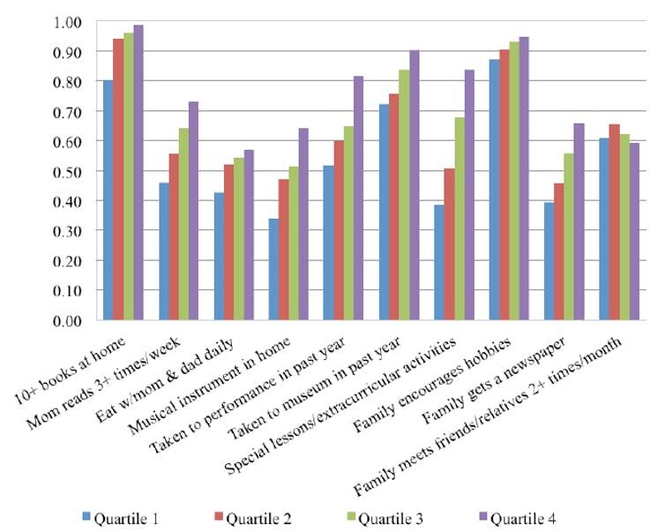
Figure 1: Special Lessons and Extracurricular Activities (Source: Caucutt, 2015)
Based on the above figure, children from rich families are more likely to attend special lessons and extracurricular activities than their counterparts from poor families. This exposes them to wider knowledge and experience.
Secondly, children from poor backgrounds perform poorly academically because of the low-quality learning conditions they are exposed to. Caucutt et al. (2015) argue that children from poor backgrounds perform poorly because of the inability of their parents to provide them with the platform to learn and resources to use in studying. The authors explain that rich parents invest a lot in their children. A statistical illustration shows that children from poor families lack adequate resources, which reduces their ability to compete with their counterparts from rich families (Caucutt et al., 2015). The authors estimate that children from rich families have at least 10 books in their homes (Caucutt et al., 2015). Further, parents from rich families have a high likelihood of about 50% more likely to be with their children and help them through assignments (Caucutt et al., 2015). This explains the disparities in academic achievement between the children from poor backgrounds and their counterparts from rich families. According to Caucutt et al. (2015), the income-based achievement gaps indicate the substantial differences in Maths and languages among school-going children. Caucutt (2015) explains that children of poorer parents perform poorly in certain subjects like Mathematics and languages by the time they start attending school. Caucutt (2015) explains that the differences in the academic achievement start with the significant differences in how much the parents are able to invest in their children. The following graph shows the level of investment that determines the differences in the way children perform in school due to differences in learning conditions. This figure shows that children from rich families get to spend more time with their parents. The parents get to read books for them. This explains why they are better than the children from poor families in reading skills.
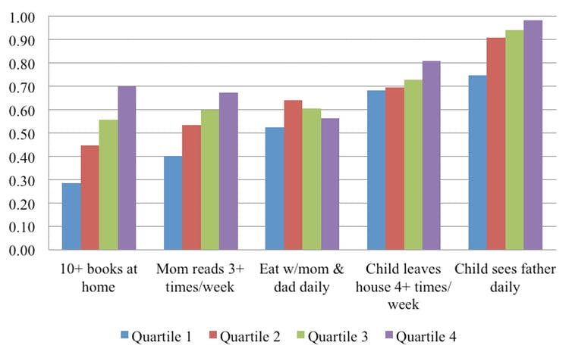
Figure 2: Rich Investment (Source: Caucutt, 2015).
Lastly, children from poor backgrounds perform poorly than their rich counterparts because of the unstable socioeconomic circumstances. Willingham (2012) tries to explain, through the family investment theories, the reasons why children in wealthier families perform significantly better than their counterparts from poor background. According to the author, children from wealthier families are exposed to better socioeconomic circumstances (Willingham, 2012). Willingham explains that children from wealthier families have advantages associated with their parents’ social and human capital. Their parents are well-connected with people who are also socially and economically abled. According to Willingham (2012), this connection exposes their children to better chances of succeeding in school than those from poor families.
Poverty is associated with many challenges including stress and depression. Based on the stress theory, Willingham (2012) explains that poverty is associated with systemic stress, which is also linked to poor socioeconomic situations. As a result, stress leads to emotional challenges in parents, which also contributes to poor parenting. The unstable socioeconomic environment, where the poor kids are raised in, contributes a lot to their cognitive and social development. Willingham (2012) explains that stress can lead directly to changes in the child’s brain, which can result in both cognitive and emotional challenges. All these can result in poor academic performance in school.
Even though some scholars believe that poor performance of children from poor families are associated with segregation, but the socioeconomic conditions contribute a lot to the cognitive and emotional development of the child. Porter (2015) blames the poor performance of the children from poor families on the historical injustices such as racial segregation. Porter (2015) explains that the majority of the children from poor families are unable to do well in schools because of the effects of racial segregation that were still fresh in the 1970s. Even though it is possible that racial segregation may have some impacts on the performance of a certain racial group, but it is not possible that children are affected immediately when they start to attend grade schools by the racial segregation factors (Gray, 2017). As Gray (2017) explains the government has tried to reduce the impact of racial segregation through the compulsory public school system. However, as many scholars agree, this has not equalized the education system because of the differences in the socioeconomic levels of the families.
In conclusion, this essay aimed at discussing the reasons why children from poor families perform poorly than their rich counterparts. It has succeeded by highlighting the three major reasons due to unmet needs, low-quality learning settings, and unstable socioeconomic conditions. Even though racial segregation may have some limited impacts on the academic performance of children, but it does not explain why the poor performance starts at the time the child starts to attend the grade level. This discussion shows that socioeconomic disparity exists at all grade levels. The poor socioeconomic levels of the households contribute to both emotional and cognitive challenges, which also result in poor performance of their children in school.

References
Caucutt, E. (April 28, 2015). “The real reason why poor kids perform worse in school- and in life.” The Washington Post. Retrieved from https://www.washingtonpost.com/posteverything/wp/2015/04/28/the-real-reason-why-poor-kids-perform-worse-in-school-and-in-life/?noredirect=on&utm_term=.65c64d9a1b98
Caucutt, E., Lochner, L., & Park, Y. (April 29, 2015). “Why Do Poor Children perform so Poorly.” Center for International Governance Innovation. Retrieved from https://www.cigionline.org/publications/why-do-poor-children-perform-so-poorly
Gray, P. (September 20, 2017). “Mend the Gap between the Rich and Poor in the School Achievement.” Psychology Today. Retrieved from https://www.psychologytoday.com/us/blog/freedom-learn/201709/mend-the-gap-between-rich-and-poor-in-school-achievement
Ratchcliffe, C. (September 2015). “Child Poverty and Adult Success.” Urban Institute. Retrieved from https://www.urban.org/sites/default/files/publication/65766/2000369-Child-Poverty-and-Adult-Success.pdf
Porter, E. (September 22, 2015). “Education Gap between Rich and Poor is Growing Wider.” The New York Times. Retrieved from https://www.nytimes.com/2015/09/23/business/economy/education-gap-between-rich-and-poor-is-growing-wider.html
Willingham, D. (March 12, 2012). “Why do Rich kids do better in Scholl than Poor kids.” Science & Education. Retrieved from http://www.danielwillingham.com/daniel-willingham-science-and-education-blog/why-do-rich-kids-do-better-in-school-than-poor-kids

